Michigan Great Start Readiness Program State Evaluation Overview

Background
Michigan has a long history of investing in preschool education. The internationally recognized High/Scope Perry Preschool Study started in Ypsilanti, MI in 1962. The researchers utilized a randomized controlled trial to follow 123 African-American children from ages 3-4 years through age 40. The study concluded that preschool experience is the best explanation for the positive effects found in the former preschool participants. Compared to the non-participants with similar backgrounds, the preschool participants were more likely to be ready for school at 5, committed to school at 14, obtain high school diploma, and earn higher income at 27, and were five times less likely to be arrested at 40. Results also showed that females and males gained different advantages from participation, with females showing lower risk of grade retention, mental impairment and high-school drop-out, and males showing reduced crime rates. Such investment also led to a large return, with every dollar spent in the program garnering $17.07 in return, benefiting both the general public and the participants.
The positive results paved the way for the launch of Michigan School Readiness Program in 1985 – the previous version of the Great Start Readiness Programs (GSRP) for at-risk 4-year-old children. Since 1995, HighScope has conducted the state evaluation using a matched comparison quasi-experimental design following 596 children from the regions of six cities: Detroit, Grand Rapids, Grayling, Kalamazoo, Muskegon and Port Huron^{[3]}. Similar to the Perry Preschool Study, this longitudinal study demonstrated better outcomes of GSRP participants across kindergarten readiness, math and reading proficiency, grade retention and high school graduation rates compared to non-participants. The completion of this longitudinal state evaluation in 2011 and several short-term cross-sectional studies in the following years all suggested that GSRP has been implemented with high fidelity, successfully delivering high quality educational experiences for 4-year-old children at heightened risk for school failure^{[4]}. The promising results reflect the State’s emphasis on quality assurance and justified continuous investment.
The Current State Evaluation Effort
While public investment in preschool has been an increasingly popular social policy and there are numerous studies documenting its positive impacts, it is not without controversy. Most critics questioned whether it is worth the investment, as some studies suggested the impacts could be minimal or fade quickly. Others challenged the validity of the studies, as many existing findings were based on small samples or subject to selection bias.
To build on the success of GSRP and help address these concerns, MSU joined the competition and was awarded the state evaluation grant in October 2017. Our long-term goal is to support Michigan becoming a Top 10 education state in 10 years. Through this longitudinal evaluation, our objectives are to support data-driven program improvement activities and to provide scientific evidence that demonstrates the impacts of the State’s investment in GSRP. The evaluation aims to answer four questions:
- Is GSRP equitably accessible to 4-year-old eligible children across geographic, racial/ethnic and income subgroups?
- How do different GSRP quality and implementation strategies relate to preschool outcomes?
- What are the academic benefits of GSRP?
- What are the economic returns to ISDs and comparative cost-effectiveness?

The Methodology for Academic Impacts
We proposed a quasi-experimental design study where the future academic performance of the GSRP participants will be compared to the performance of the waitlist children. The waitlist children are defined as GSRP applicants who complete the application process but never attend a publicly funded preschool program. Given the limited study period, the academic outcomes to be focused include: students receiving special education, grade retention, suspension/expulsion, absenteeism (missing more than 10 school days in a semester), and M-STEP English Language Arts and Mathematics scores. The rationale is that if GSRP is effective, GSRP children should achieve positive learning outcomes and sustain those positive outcomes as they get older compared to the waitlist children. The waitlist children form a good comparison group based on quasi-experimental design standards because they are more like the GSRP families (in terms of being aware of and motivated to enroll) than a matched control group exclusively based on income and demographic characteristics. Access to such data is currently pending for approval.

The Methodology for Economic Impacts
We proposed to translate the academic impacts into dollar amounts in terms of ISD and the state saving on special education, grade retention and absenteeism expenditures. We are currently exploring options with Michigan Department of Education (MDE) to collect additional information on local grantee’s in-kind contributions (i.e., busing) and other funding sources (i.e., Title I, food programs, school improvement grants) that support GSRP classrooms to get a more accurate picture of true cost.

The Overview of the Available Data
Mainly utilizing the secondary data for analysis, our goal is to identify a way to retrieve data from different sources and connect them in an efficient way to maximize data usage. Given the natural layers of data structure, our design of the analysis will account for the nested effects. The highest level for data collection is at the ISDs, focusing on the funding amount and utilization. Because ISDs select local subrecipients to manage regional sites, the second level for analysis will be how different types of the subrecipients, the expenditures and the serving capacities between Head Start and GSRP classrooms might relate to the outcomes. Subrecipients usually manage multiple sites, with each site having a valid childcare licensing number. At the site level, we will examine how varying site types, geographic locations, and curriculum and assessment tools used for the sites might show different results. At the classroom level, data around program quality assessments (i.e., PQA-R, CLASS), teacher credentials and salaries and classroom options (school-day, half-day and Head Start blend) will be used for analysis. For data related to students’ characters and academic performance, a data sharing agreement between MSU’s Community Evaluation and Research Collaborative (CERC) at University Outreach and Engagement and Michigan’s Center for Educational Performance and Information (CEPI) has been executed in October 2018. Notably, because the State collects child data from the whole program site, not individualized by classrooms, all the classroom data will be compiled at the program site for analysis. An overview of the data availability at different levels can be found in Figure 1 (Use powerpoint for the website).
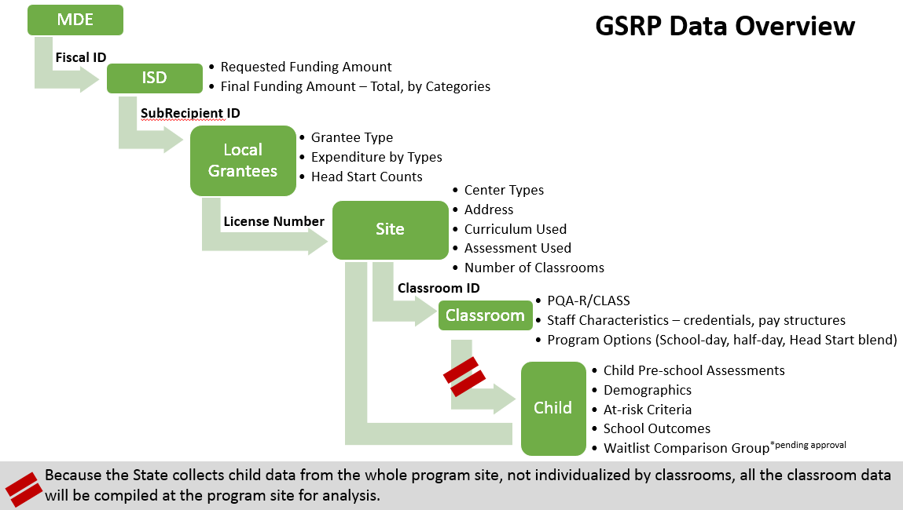

The MSU Team
Our team consists of collaborators from MSU’s interdisciplinary and cross-institutional backgrounds with experiences working on multi-site evaluations in K-12 and early childhood program settings. All the senior personnel are well-experienced with large-scaled data collection, management and analysis, and are expected to widely disseminate the findings through the affiliated networks across the fields of evaluation, education, child development, economy, social policies, and statistics.
Heng-Chieh (Jamie) Wu, Principal Investigator, recreation and youth development. K-12 out-of-school time, program evaluation, hierarchical linear modeling, Co-PI for the Michigan 21st Century Community Learning Centers (CCLC) statewide evaluation project. Dr. Wu has had more than a decade of experiences conducting K-12 out-of-school time program evaluation and was named as one of the Most Influential in Research and Evaluation 2018 by the National AfterSchool Association.
Laurie Van Egeren, Co-Principal Investigator, developmental psychology. Child development, cluster randomized trial, Co-PI for the Michigan 21st CCLC statewide evaluation, PI for NSF-funded Head Start on Science, Co-PI for NSF-funded Advancing Research and its Impact on Society (ARIS) Center. Dr. Van Egeren is the interim associate provost for University Outreach and Engagement and her works emphasize community-engaged scholarships and translating research to the public.
Frank Lawrence, Investigator, senior statistician. Longitudinal latent growth modeling, mixture modeling, hierarchical linear modeling. Dr. Lawrence serves as the lead statistician and oversees the analytic framework for the longitudinal examination of the GSRP impacts.
Steven Miller, Investigator, policy economist. Applied economic methods for economic modeling and for monitoring and evaluation. Dr. Miller is the Director of the Center for Economic Analysis, and serves as the lead economist focusing on the economic impacts of GSRP.
KyungSook Lee, Investigator, human development and family studies. Structural equation modeling, system dynamics modeling. Dr. Lee is the quantitative data manager, supervises undergraduate students, assists with the data analysis and reports writing.
Miles McNall, Lead Advisor, sociologist. School-based health centers, childhood and youth mental health systems. Dr. McNall is the Director of the Community Evaluation and Research Collaborative, and facilitates GSRP advisory committee meetings.

